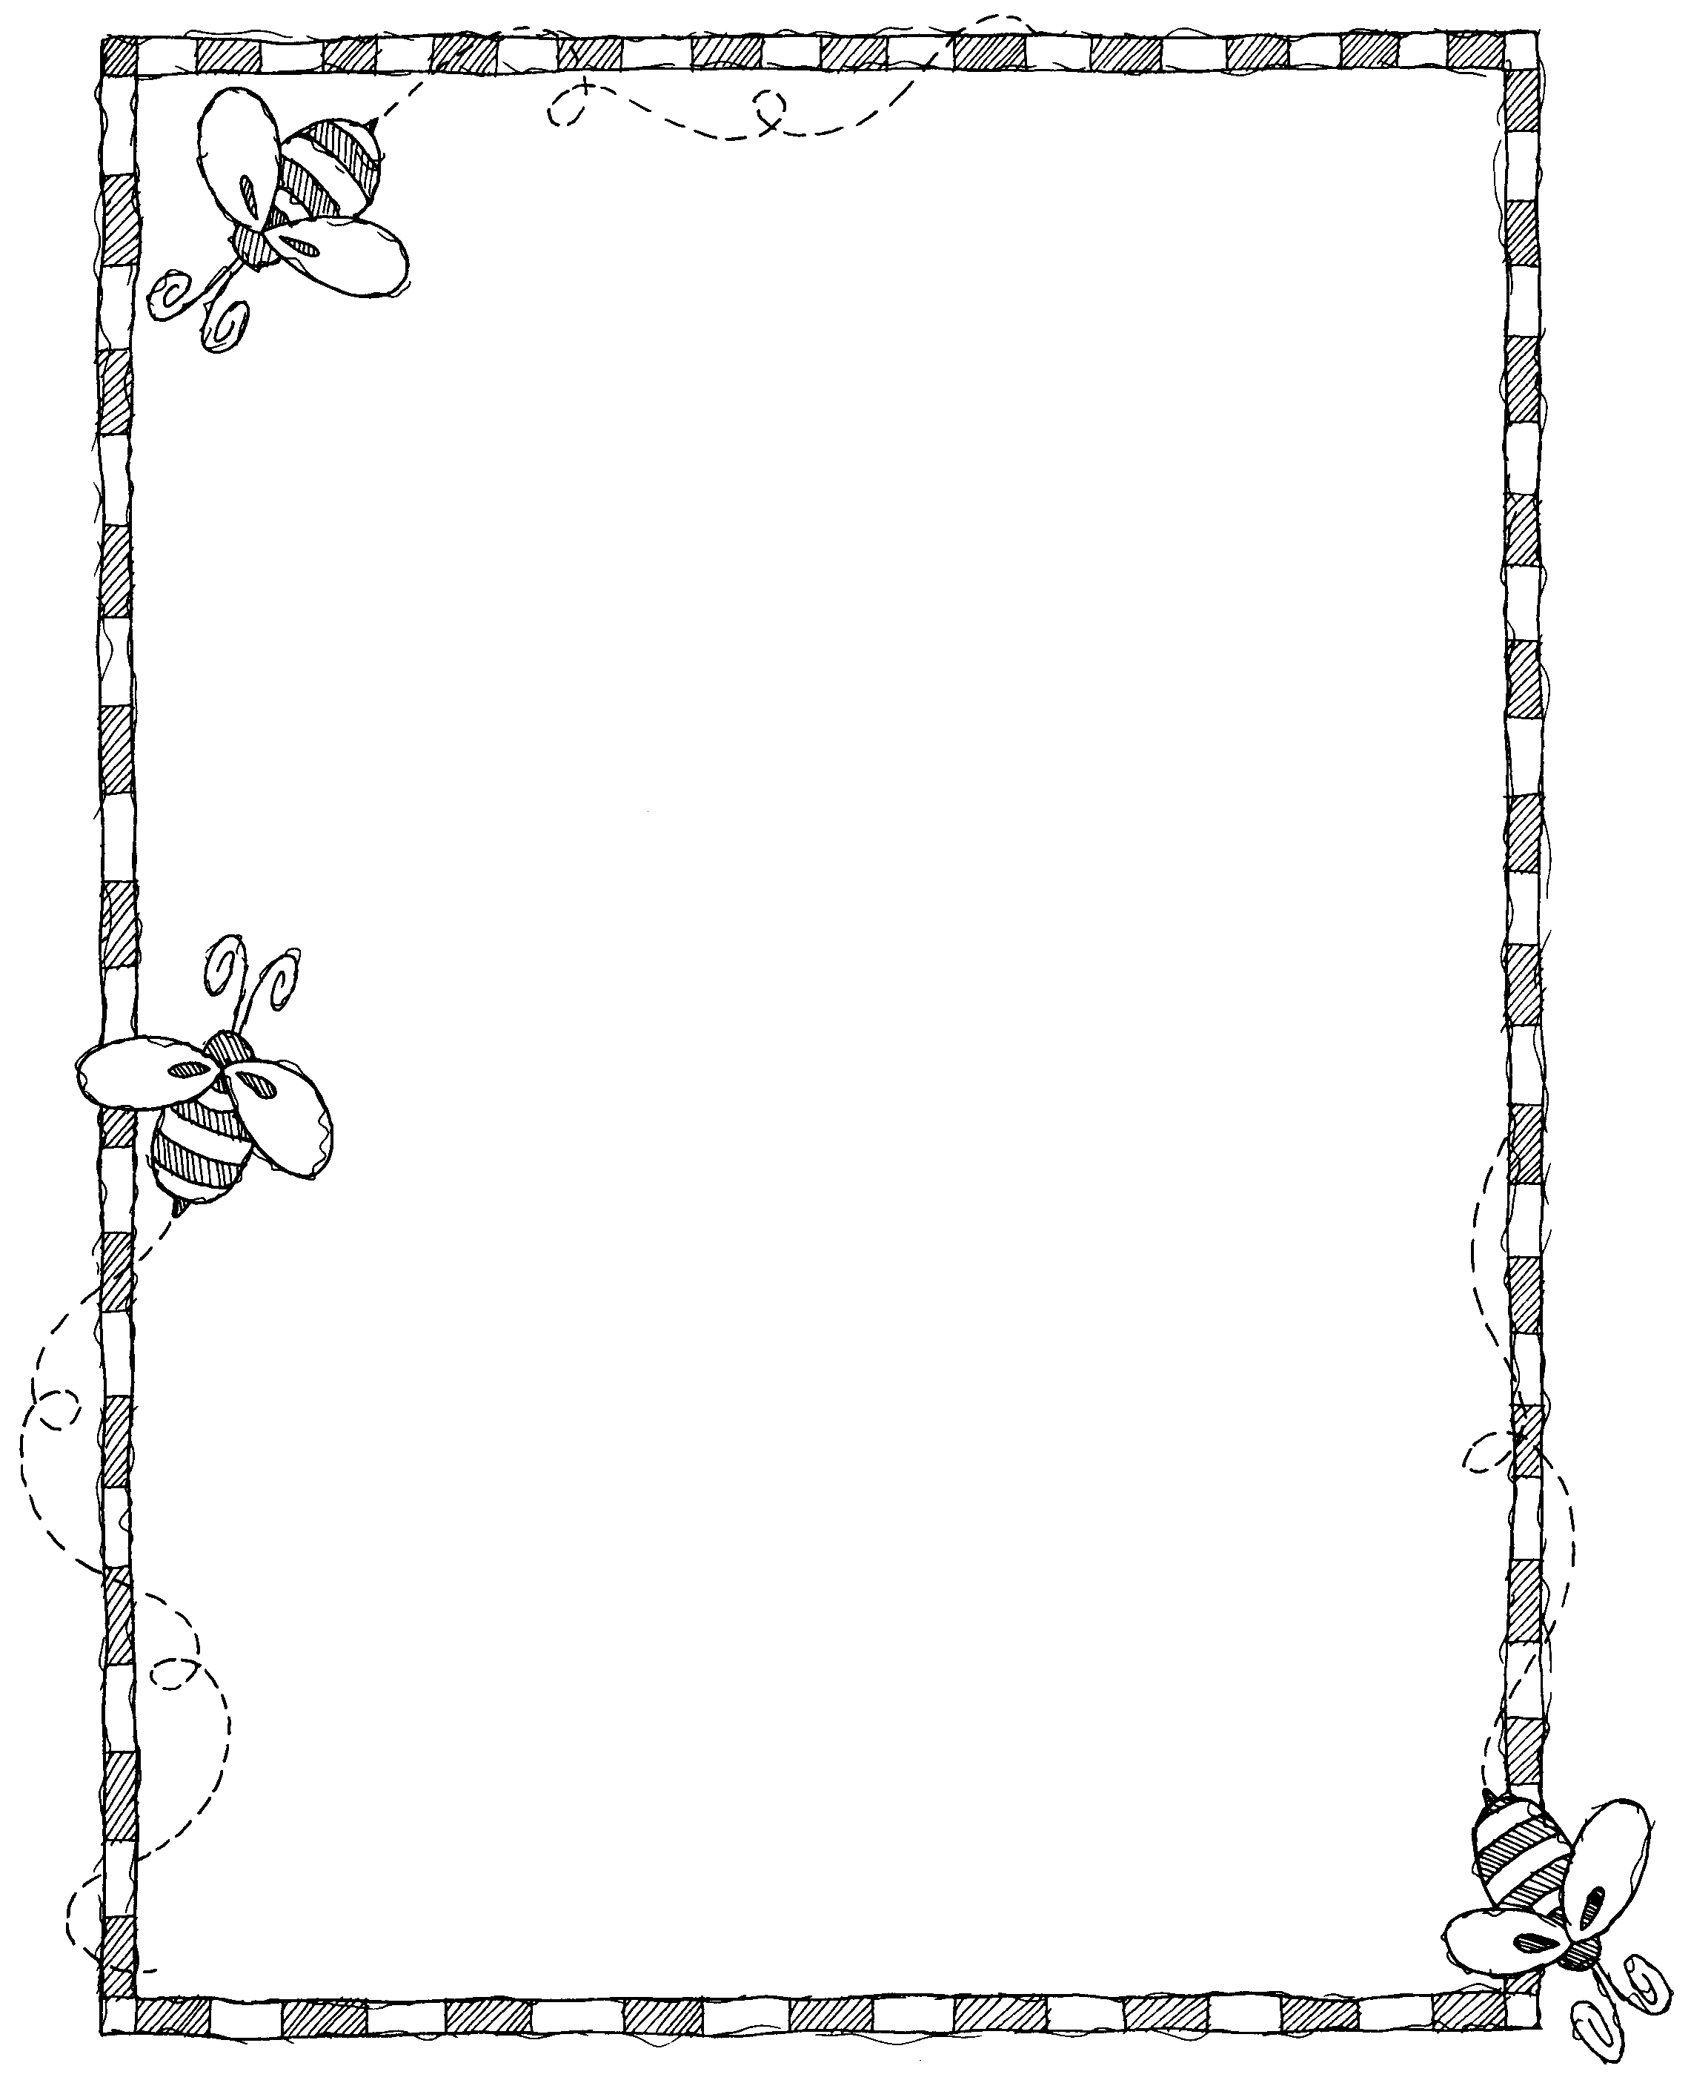
Learning Resources for Families

WEBSITES: Together, you and your children can explore these internet web sites. Most have games that you can play at the site (or download) as well as activity pages to print off.

* WVIZ www.pbskids.org
Word World, Curious George, Clifford, Seasame
Street

* Starfall.com - a variety of preacademic skills

APPS: Good apps or resources to find apps that you and your kids may enjoy

Articulation: Articulation Station, Artic PCS, Artik Pix, Webber Artic Castle

Fun & interactive to work on Vocabulary: My Play Home, Toca Boca Birthday party, 5 Monkeys, Clicky Sticky apps, Ice Cream, Mr. Potato Head, Sticker World, PCS Memory, PCS Bingo, Photo Touch Concepts, Farmyard by Make A Scene

Positional words: Fun with Directions, More Fun with Directions, Splingo

I Can Do apps – categories, associations, rhyming, phonics, emotions

* SmartAppsForKids.com – list of recommended apps by category and you can sign up for notices of when free apps are available for free

